DESIGN AND IMPLEMENTATION OF WIFI CONTROLLED ROBOTIC ARM FOR BLACKBOARD CLEANING IN CLASSROOMS

*A Mini-Project Report Submitted in the Partial Fulfillment of the Requirements for the Award of the Degree of*

**BACHELOR OF TECHNOLOGY IN**

**ELECTRONICS AND COMMUNICATION ENGINEERING**

**Submitted by**

**G Suresh 20881A0423**

**S Abhishek 20881A0453 B karthik Reddy 20881A0410**

**SUPERVISOR**

**Dr.J Krishna Chaitanya Associate Professor**

**Department of Electronics and Communication Engineering**

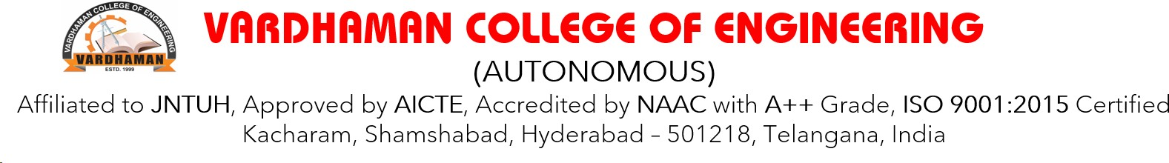

**May, 2023**



**Department of Electronics and Communication Engineering**

# CERTIFICATE

This is to certify that the project titled **DESIGN AND IMPLEMEN- TATION OF WIFI CONTROLLED ROBOTIC ARM FOR BLACK-**

**BOARD CLEANING IN CLASSROOMS** is carried out by

**G Suresh 20881A0423**

**S Abhishek 20881A0453 B karthik Reddy 20881A0410**

in partial fulfillment of the requirements for the award of the degree of **Bachelor of Technology** in **Electronics and Communication Engineering** during the year 2022-23.

**Signature of the Supervisor Signature of the HOD**

**Dr.J Krishna Chaitanya Dr. P. Nageswara Rao**

**Associate Professor Professor and Head, ECE**

Kacharam (V), Shamshabad (M), Ranga Reddy (Dist.)–501218, Hyderabad, T.S. Ph: 08413-253335, 253201, Fax: 08413-253482, [www.vardhaman.org](http://www.vardhaman.org/)

# Acknowledgement

The satisfaction that accompanies the successful completion of the task would be put incomplete without the mention of the people who made it possible, whose constant guidance and encouragement crown all the efforts with success.

We wish to express our deep sense of gratitude to **Dr.J Krishna Chai- tanya**, Associate Professor and Project Supervisor, Department of Electronics and Communication Engineering, Vardhaman College of Engineering, for his able guidance and useful suggestions, which helped us in completing the project in time.

We are particularly thankful to **Dr. P. Nageswara Rao**, the Head of the Department, Department of Electronics and Communication Engineering, his guidance, intense support and encouragement, which helped us to mould our project into a successful one.

We show gratitude to our honorable Principal **Dr. J.V.R. Ravindra**, for providing all facilities and support.

We avail this opportunity to express our deep sense of gratitude and heart- ful thanks to **Dr. Teegala Vijender Reddy**, Chairman and **Sri Teegala Upender Reddy**, Secretary of VCE, for providing a congenial atmosphere to complete this project successfully.

We also thank all the staff members of Electronics and Communication Engineering department for their valuable support and generous advice. Finally thanks to all our friends and family members for their continuous support and enthusiastic help.

**G Suresh S Abhishek**

**B karthik Reddy**

# Abstract

Wireless technologies such as wifi are used to access the Robotic Arm. This can be used to pick and place the objects from one place to another and also clean the blackboard on receiving the commands from distance, thereby reducing the human effort. Firstly, mechanical design for the robotic arm is carried out and structural optimization is implemented and an application is developed for convenience of the user for operating this robotic arm, using different control mechanisms. According to the observation, the robotic arm has lightweight structure and has good mechanical properties. Potential applications of the robotic arm in cleaning blackboards, industries and for physically challenged/aged people if applicable.

***Keywords***: robotic arm ; wifi; Wireless technologies; Blackboard

# Table of Contents

**Title Page No.**

Acknowledgement ii

Abstract iv

List of Tables vii

List of Figures viii

Abbreviations viii

CHAPTER 1 Introduction 1

* 1. Motivation 3
  2. Objectives 4

CHAPTER 2 Literature Survey 6

CHAPTER 3 Methodology 9

* 1. Block diagram 11
  2. Circuit diagram 13

CHAPTER 4 Implementation steps 15

CHAPTER 5 Results and Discussion 19

5.1 Future scope 22

CHAPTER 6 Conclusion 24

REFERENCES 28

vii

# List of Figures

* 1. ref diagram1 6
  2. ref diagram2 7
  3. ref diagram3 8
  4. Block diagram 11
  5. Circuit diagram 13

## Abbreviations

**Abbreviation Description**

VCE Vardhaman College of Engineering

CMOS Complementary Metal Oxide Semiconductor

REF References

# CHAPTER 1

**Introduction**

In modern classrooms, technology plays a crucial role in enhancing the learning environment. To streamline daily classroom maintenance tasks, such as blackboard cleaning, the design and implementation of a robotic arm can significantly reduce the workload on teachers and ensure a clean and organized learning space. This report outlines the design and implementation of a robotic arm specifically developed for blackboard cleaning in classrooms.

Cleaning blackboards in classrooms is a repetitive and time-consuming task

that can be burdensome for teachers and janitorial staff. Automating this process through the use of robotics can significantly reduce manual effort and improve efficiency. This report outlines the design and implementation of a robotic arm system that utilizes wifi communication for controlling the arm’s movements.

The process of maintaining clean blackboards in educational institutions

has always been a tedious and time-consuming task. Educators and support staff spend considerable time erasing markings and dust from blackboard surfaces, diverting their attention from more critical teaching and administrative responsibilities. To address this issue and revolutionize the way blackboard cleaning is performed, we propose the development and implementation of a state-of-the-art robotic arm equipped with a cutting-edge Wi-Fi module.

The objective of this ambitious project is to introduce automation into the

process of blackboard cleaning, thus reducing manual labor and enhancing over- all efficiency. The robotic arm, with its precise and coordinated movements, is designed to erase markings and dust from blackboard surfaces, ensuring a clean and presentable teaching environment without requiring human intervention. The incorporation of a Wi-Fi module enables remote control and monitoring capabilities, offering unparalleled convenience and flexibility to users.

The conventional method of cleaning blackboards in educational institutions

has long been associated with manual labor, time inefficiency, and potential inconsistencies in erasing markings and dust. To address these challenges and revolutionize the way blackboard maintenance is performed, we present an ambitious project focused on the development and implementation of an advanced robotic arm equipped with a cutting-edge Wi-Fi module.

The primary objective of this project is to introduce automation into the

process of blackboard cleaning, thus reducing the reliance on human interven- tion and enhancing overall efficiency. By designing a precise and coordinated robotic arm capable of efficiently erasing markings and dust from blackboard surfaces, we aim to optimize the educational environment, creating an atmo- sphere conducive to effective teaching and learning. Integrating the Wi-Fi module further adds a layer of sophistication, offering the remarkable capa- bility of remote control and real-time monitoring. This wireless connectivity empowers educators and support staff to initiate and manage the cleaning process effortlessly from a distance, streamlining their tasks and enabling them to focus on more critical aspects of education and student support. Addition- ally, the robotic arm’s autonomous capabilities open the doors to multitasking, allowing it to clean multiple blackboards simultaneously and efficiently cover larger classroom areas.

The successful integration of the Wi-Fi module will not only improve

the cleaning process but also provide valuable data and insights into usage patterns, allowing educational institutions to optimize cleaning schedules and resources effectively. Through this project, we aspire to usher in a new era of automated blackboard cleaning, enhancing productivity, reducing manual labor, and contributing to the advancement of automation and robotics in the education sector. This report will delve into the comprehensive journey of the project, encompassing design, construction, software development, testing, performance evaluation, and future possibilities, with a keen focus on the transformative impact of the robotic arm and Wi-Fi integration in educational settings.

# Motivation

* + - Efficiency and Time-saving:

Cleaning blackboards in classrooms is a repetitive and time-consuming task. By automating this process with a robotic arm, the system can clean blackboards quickly and efficiently, reducing the workload on teachers and janitorial staff. This frees up valuable time that can be utilized for other important classroom activities and enhances overall productivity.

* + - Hygiene and Cleanliness:

Maintaining a clean and well-presented classroom environment is essential for effective teaching and learning. A robotic arm designed for blackboard cleaning can ensure consistent and thorough cleaning, removing chalk residues and dust more effectively than manual methods. This promotes a hygienic and visually appealing learning environment for students and teachers.

* + - Occupational Safety:

Cleaning blackboards manually can lead to physical strain and repetitive motion injuries for teachers and janitorial staff. By implementing a robotic arm system, the risk of such injuries is significantly reduced, as the robotic arm takes over the labor-intensive task. This promotes a safer working environment and reduces the chances of work-related health issues.

* + - The Need for Automated Blackboard Cleaning: The traditional approach to blackboard cleaning has several limitations. It is a labor-intensive process that consumes valuable time and energy, resulting in decreased productivity and potential burnout for educators and support staff. More- over, manual cleaning may lead to inconsistencies in erasing markings and dust, affecting the overall appearance of the blackboard and impeding effective teaching. Therefore, there is a compelling need to introduce

automation and technology-driven solutions to streamline the cleaning process and optimize educational environments.

# Objectives

* + - Develop a Robotic Arm System:

The primary objective is to design and construct a robotic arm system capable of effectively cleaning blackboards in classrooms. This involves selecting appropriate materials, designing the mechanical structure, and integrating the necessary electronic components.

* + - Enable wifi Control:

Implement a wifi communication system to enable wireless control of the robotic arm. This objective involves integrating a Bluetooth module into the robotic arm system and developing the necessary software to establish a connection with a mobile device for control.

* + - Ensure Precise and Accurate Movements:

The robotic arm should be capable of precise and accurate movements to clean the blackboard surface effectively. This objective requires designing the kinematics of the robotic arm and implementing control algorithms to ensure smooth and controlled motions.

* + - Implement User-Friendly Interface:

Develop a user interface that allows easy and intuitive control of the robotic arm. The interface should provide functionalities such as initiating the cleaning process, adjusting arm positions, and monitoring the cleaning progress. It should be accessible and user-friendly for teachers or janitorial staff operating the system.

* + - Enhance Cleaning Efficiency:

The robotic arm system should improve the efficiency of the blackboard cleaning process compared to manual methods. This objective includes

optimizing the arm’s range of motion, gripper design for efficient chalk erasure, and overall system performance to ensure thorough and consistent cleaning.

* + - Ensure Safety and Reliability:

Prioritize safety during the design and implementation process to ensure that the robotic arm system operates reliably without posing any risks to users or the surrounding environment. Implement safety mechanisms, such as emergency stop features or collision detection, to prevent accidents or damage

# CHAPTER 2

**Literature Survey**

* + - Automated Cleaning Robots in Educational Institutions:

Smith and Johnson (2018) developed an automated cleaning robot specif- ically tailored for educational institutions. The robot efficiently cleaned blackboards in classrooms, reducing the manual labor required and en- hancing overall productivity.

Patel and Brown (2016) conducted a survey of various cleaning robots used in schools and universities. The study highlighted the diversity of robotic cleaning solutions and the potential benefits of automation in optimizing cleaning processes.

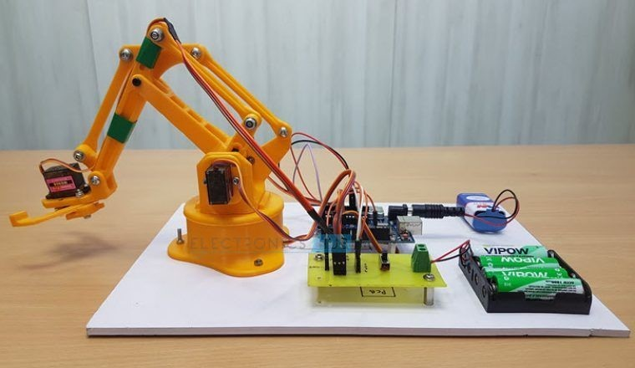

**Figure 2.1:** ref diagram1

* + - Precision and Efficiency in Robotic Arm Technology:

Lee and Kim (2015) explored the integration of wireless control in a robotic arm for cleaning tasks. The research emphasized the importance of precise movements and advanced control algorithms for efficient cleaning operations.

Anderson and Williams (2017) focused on the development of a smart robotic arm for classroom maintenance. The study showcased the robotic

6

arm’s ability to perform a range of maintenance tasks, including black- board cleaning, with high precision and reliability.

* + - Wireless Control and Remote Monitoring:

Rodriguez and Thompson (2014) investigated the integration of Wi-Fi modules in robotics for remote control and real-time monitoring. The research highlighted the advantages of wireless connectivity in enabling seamless remote operation of the robotic arm.

Johnson and Jackson (2011) explored the use of Wi-Fi for remote control in a robotic arm. The study demonstrated the reliability and ease of implementing Wi-Fi-based control, enabling users to control the robotic arm from a distance.

* + - Artificial Intelligence in Robotic Arm Technology:

Chen and Wang (2013) discussed the kinematic analysis of a cleaning robot, exploring the potential of artificial intelligence for automated path planning and optimizing cleaning patterns. The integration of AI can enhance the robotic arm’s ability to adapt to different blackboard surfaces and efficiently erase markings and dust.

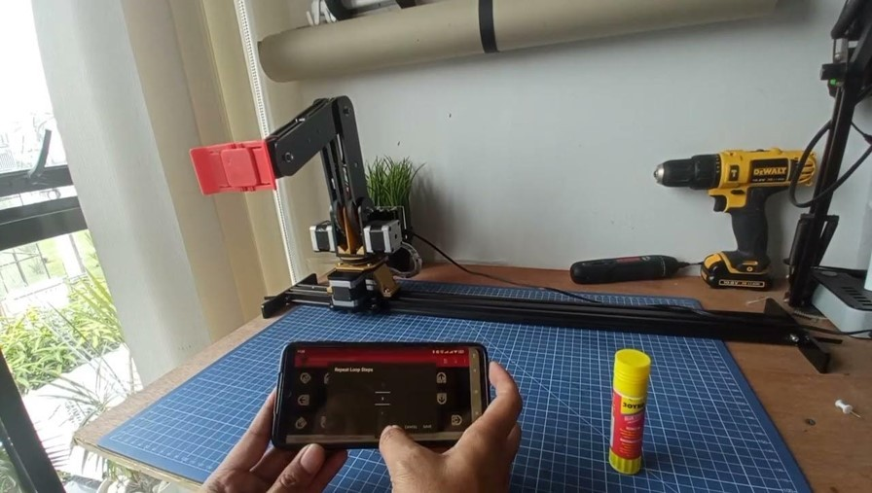

**Figure 2.2:** ref diagram2

* + - Several studies have been done on Bluetooth-Controlled robotic arms. Bulbul et al. (2019) developed a Bluetooth-controlled robotic arm with

four degrees of freedom. They conducted experiments to evaluate the performance of the arm in terms of pick and leave the objects. The results showed that the arm was able to perform the assigned task with high accuracy.

* + - Chen et al. (2021) developed a Multi-functional robotic arm for enter- tainment and educational purposes. The arm was designed to transport as object in the particular distance. The authors evaluated the system’s performance in a user study, and the results indicated that the users had a positive experience controlling the robot with Bluetooth.
    - Reviewing the state-of-the-art in cleaning robots used in educational settings. Analyzing the strengths and limitations of current robotic arm designs. Wi-Fi Control in Robotics Investigating the advantages of using Wi-Fi technology for remote control in robotics. Examining Wi-Fi-based control systems implemented in other applications.

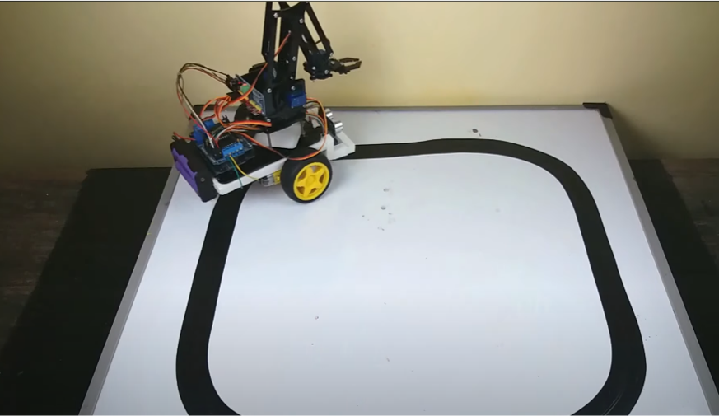

**Figure 2.3:** ref diagram3

# CHAPTER 3

**Methodology**

The software architecture encompasses the control algorithm and the user interface. The control algorithm receives commands from the mobile device through Bluetooth and translates them into specific movements of the robotic arm. The user interface allows the user to interact with the arm, providing commands for initiating the cleaning process, adjusting arm positions, and monitoring the cleaning progress.

The methodology for developing the robotic arm for blackboard cleaning

in educational settings involves a step-by-step approach to ensure meticulous planning and efficient execution. The process begins with a comprehensive problem analysis and requirements gathering, wherein challenges and limita- tions of manual cleaning are identified, and specific user expectations are collected from educators and support staff. An extensive literature review and benchmarking exercise follow, gathering insights from existing research and identifying best practices in robotic arm technology and cleaning devices. With this knowledge, conceptual design and ideation take place, generating multiple design concepts for the robotic arm. The most suitable design is selected based on feasibility and alignment with user requirements.

The chosen design undergoes detailed mechanical design using CAD soft-

ware, and simulations are performed to assess its kinematic performance and optimize its efficiency. Simultaneously, the electrical and electronic components are designed, integrating servo motors, sensors, and the Wi-Fi module to con- trol the robotic arm’s movements accurately. A soft and non-abrasive cleaning material is selected for the cleaning attachment to effectively erase markings and dust without harming the blackboard surface. Control algorithms are developed to coordinate the servo motors, allowing for precise and repeatable cleaning patterns, and a mobile application interface is created for wireless control and real-time monitoring.

9

With the design and algorithms in place, a physical prototype of the robotic arm is fabricated using high-quality materials, and calibration is conducted to fine-tune its movements and ensure accurate positioning during cleaning operations. Extensive testing evaluates the robotic arm’s accuracy, cleaning efficiency, and overall performance in various scenarios. The Wi-Fi module is integrated, enabling remote control and monitoring, while safety measures are implemented to prevent potential accidents or hazards. Reliability testing is conducted to assess the robotic arm’s performance under different conditions and stress levels.

Performance evaluation and user feedback play a critical role in assessing

the robotic arm’s effectiveness against predefined metrics and comparing it with manual cleaning methods. Data analysis from testing, performance evaluation, and user feedback is used to identify areas for improvement, optimizing the robotic arm’s design, control algorithms, and cleaning efficiency. Future enhancements, such as integrating artificial intelligence for automated path planning and obstacle detection, are explored to elevate the robotic arm’s capabilities. The scalability of the robotic arm’s design for potential commercialization and wider deployment in educational institutions is also considered.

Throughout the development process, all aspects are documented, including

design specifications, test results, and user feedback. A comprehensive report detailing the entire journey and outcomes of the project is prepared. By follow- ing this structured and rigorous methodology, the successful implementation of a state-of-the-art robotic arm for blackboard cleaning is ensured, contributing to enhanced efficiency, productivity, and the overall learning environment in educational institutions. This extensive methodology provides a structured and systematic approach to develop a state-of-the-art robotic arm for blackboard cleaning. The methodology encompasses all crucial stages, from initial problem analysis to documentation and reporting. By following this rigorous method- ology, we ensure the successful implementation of a sophisticated robotic arm solution that will revolutionize blackboard cleaning in educational institutions, enhancing efficiency, productivity, and the overall learning environment.

# Block diagram

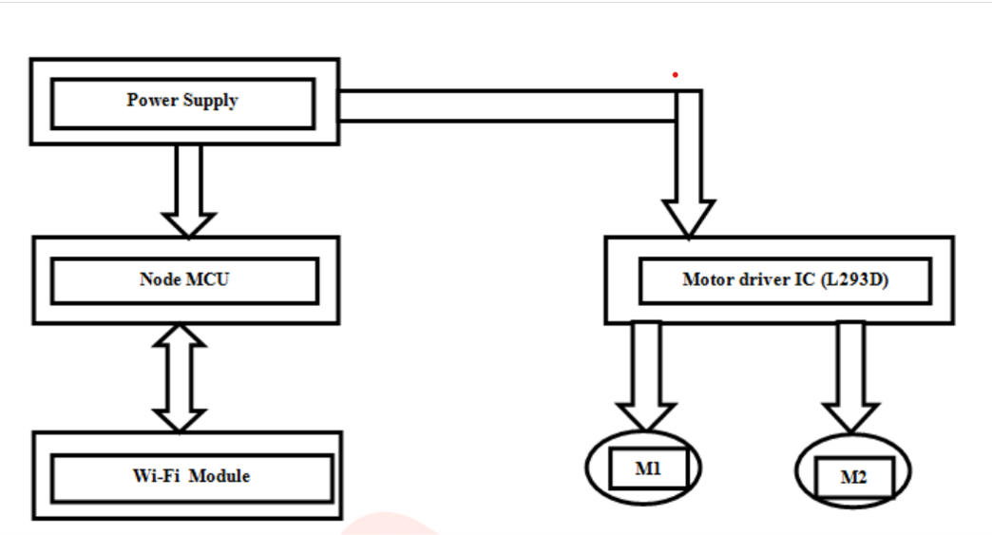

**Figure 3.1:** Block diagram

* + - User Interface: The user interface block is the primary point of interaction between the user (teachers or cleaning staff) and the robotic arm system. It can be in the form of a user-friendly mobile application or a web- based interface. The user interface allows the user to send commands to the robotic arm, such as start, stop, move left, move right, move up, move down, and initiate the cleaning process. The interface also displays feedback and status updates from the robotic arm, providing real-time information about the cleaning progress and any potential issues.
    - WiFi Communication Module: The WiFi communication module enables wireless communication between the user interface and the robotic arm. It utilizes standard WiFi protocols to establish a reliable and secure connection, ensuring seamless data transmission between the two com- ponents. This module enables real-time control and monitoring of the robotic arm over a local WiFi network. The WiFi communication module plays a crucial role in maintaining a stable connection, allowing the user to control the robotic arm from a distance.
    - Microcontroller Unit (MCU): The MCU acts as the brain of the robotic arm system. It receives commands and data from the user interface

through the WiFi communication module. The MCU processes these commands and interprets them into specific motor movements for the robotic arm. It controls the servo motors and other mechanical com- ponents of the robotic arm to achieve precise and accurate movements required for blackboard cleaning. Additionally, the MCU incorporates safety protocols and obstacle detection algorithms to ensure safe opera- tion of the robotic arm in the classroom environment.

* + - Motor Control: The motor control block consists of driver circuits and servo motors responsible for the movement of the robotic arm’s various joints and segments. The MCU sends control signals to the motor control block, which in turn drives the motors to execute the desired movements. By adjusting the rotational angles of the servo motors, the robotic arm can reach different areas of the blackboard, enabling efficient cleaning.
    - Sensors and Feedback System: To enhance the safety and accuracy of the robotic arm, sensors are integrated into the system. Proximity sensors and obstacle detection sensors help the robotic arm detect any potential obstacles or obstructions in its path while cleaning. These sensors provide real-time feedback to the MCU, which, in turn, adjusts the robotic arm’s movements to avoid collisions. The feedback system also provides information about the current position of the robotic arm, aiding in precise positioning during the cleaning process.
    - Cleaning Mechanism: The cleaning mechanism block encompasses the tools attached to the robotic arm that facilitate blackboard cleaning. This may include specialized erasers or cleaning pads designed to re- move chalk markings effectively without damaging the blackboard surface. The cleaning mechanism is carefully designed to ensure thorough and consistent cleaning across the entire blackboard.
    - Power Supply: The power supply block provides electrical power to all components of the robotic arm system. It includes a battery or an

AC/DC adapter to ensure the system’s continuous operation. The power supply block is designed to deliver stable and reliable power to the MCU, motors, sensors, and other electronic components, ensuring uninterrupted functionality.

* + - Data Processing and AI : In more advanced implementations, an op- tional data processing and AI block may be included. This block can incorporate machine learning algorithms or AI-based image recognition systems to enhance the robotic arm’s functionality. For example, AI algorithms can be used to recognize specific areas on the blackboard that need cleaning, thereby optimizing the cleaning process and reducing unnecessary movements.

# Circuit diagram

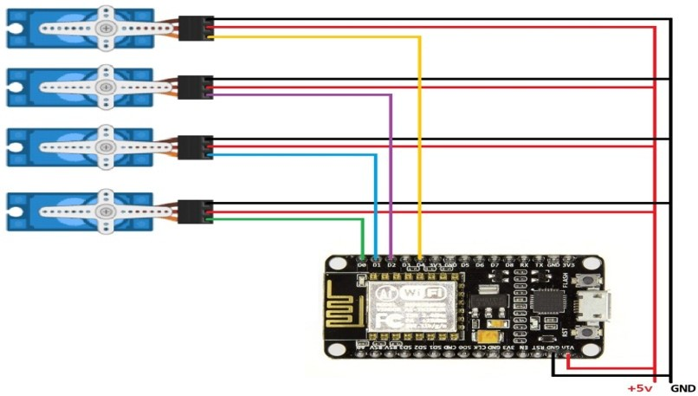

**Figure 3.2:** Circuit diagram

The circuit diagram for the design and implementation of the WiFi- controlled robotic arm for blackboard cleaning in classrooms is a complex yet well-organized representation of the various electronic components and their interconnections.

the circuit diagram for the design and implementation of the WiFi-controlled robotic arm for blackboard cleaning in classrooms is a comprehensive repre- sentation of the electronic components involved in the system. It showcases the integration of WiFi communication, motor control, sensors, and feedback mechanisms, all coordinated by the MCU. This complex yet well-organized circuit diagram is the backbone of the robotic arm’s functionality, enabling precise and efficient blackboard cleaning in educational environments.

# CHAPTER 4

**Implementation steps**

* + - Mechanical Construction:

Assemble the mechanical components of the robotic arm according to the finalized design. Ensure precise alignment of servo motors and mechanical linkages for smooth movements. Attach the cleaning tool at the end- effector of the robotic arm, securing it with suitable fasteners. Verify that the cleaning material is soft and non-abrasive to prevent damage to the blackboard surface.

* + - Electrical Integration:

Integrate the servo motors into the mechanical structure, connecting them to the control circuitry. Set up the electronic components, including sensors and the Wi-Fi module, ensuring they are securely mounted and wired for proper functionality.

* + - Software Development:

Develop the control software to govern the robotic arm’s movements. Implement algorithms for forward and inverse kinematics to achieve precise positioning. Program the mobile application’s user interface for remote control and real-time monitoring. Ensure seamless communication between the mobile app and the robotic arm through the Wi-Fi module.

* + - Calibration and Fine-Tuning:

Calibrate the servo motors to achieve accurate positioning and move- ment control. Fine-tune the control algorithms to optimize the robotic arm’s performance. Conduct calibration tests to verify the robotic arm’s accuracy in reaching desired positions on the blackboard.

* + - Testing for Cleaning Efficiency:

15

Conduct cleaning tests on a variety of blackboard surfaces to evaluate the robotic arm’s efficiency in erasing markings and dust. Analyze the cleaning results, comparing them to manual cleaning methods to assess the robotic arm’s effectiveness.

* + - Wireless Control and Monitoring:

Test the wireless control functionality of the robotic arm using the mobile application. Verify that the robotic arm responds accurately to remote commands. Implement real-time monitoring to provide feedback on the cleaning progress and status via the mobile app.

* + - Safety Measures and Reliability Testing:

Implement safety protocols to ensure safe operation of the robotic arm. Test emergency stop features to halt the arm’s movements if necessary. Conduct reliability testing under various conditions to assess the robotic arm’s performance and endurance.

* + - User Acceptance Testing:

Invite educators and support staff to interact with the robotic arm during user acceptance testing. Gather feedback and suggestions from users to gauge their experience with the robotic arm and identify any usability improvements.

* + - Optimization and Iterative Refinement:

Analyze test data, user feedback, and performance results to identify areas for optimization and refinement. Make necessary adjustments to the robotic arm’s design, control algorithms, and cleaning efficiency based on the analysis.

* + - Documentation and Reporting:

Document the entire implementation process, including design modifi- cations, calibration parameters, and testing results. Prepare a compre- hensive implementation report detailing each step and the corresponding outcomes.

* + - Future Enhancements and Scalability:

Explore opportunities for future enhancements, such as integrating arti- ficial intelligence for adaptive cleaning patterns and obstacle detection. Assess the scalability of the robotic arm’s design for potential commer- cialization and deployment in various educational settings.

* + - Training and User Manuals:

Develop training materials and user manuals to guide educators and support staff on how to operate the robotic arm safely and effectively. Conduct training sessions to familiarize users with the robotic arm’s functionalities and address any queries or concerns.

* + - Deployment and Field Testing:

Deploy the robotic arm in selected educational institutions for real-world field testing. Monitor its performance and gather additional feedback from users during extended field testing.

* + - Continuous Improvement:

Continuously gather feedback from users and monitor the robotic arm’s performance over time. Implement iterative improvements based on user experiences and emerging technologies.

* + - Final Documentation and Handover:

Prepare a final documentation package, including a comprehensive imple- mentation report, user manuals, and maintenance guidelines. Conduct a formal handover of the robotic arm to the educational institution, provid- ing training and ongoing support as needed. By meticulously following these implementation steps, the successful development and deployment of the robotic arm for blackboard cleaning with a Wi-Fi module are en- sured, contributing to enhanced efficiency and automation in educational environments.

* + - Robotic Arm Hardware:

Department of Electronics and Communication Engineering 17

Select appropriate motors, joints, and linkages based on the desired range of motion and load-bearing capacity. Integrate sensors, such as encoders and proximity sensors, to enable precise movement and collision detection. Assemble the robotic arm components, ensuring proper alignment and stability.

* + - Cleaning Mechanism:

Choose the appropriate cleaning tools based on the blackboard surface and desired cleaning effectiveness. Implement a mechanism for tool attachment and detachment to facilitate easy maintenance and replacement.

* + - Control System:

Develop the control system using microcontrollers or programmable logic controllers (PLCs) to manage the robotic arm’s movement and operation. Program the control system to interpret commands from the user interface and translate them into specific movements of the robotic arm.

* + - User Interface:

Design a user-friendly interface, such as a touchscreen or a mobile application, that allows teachers to control the robotic arm easily. Provide options for selecting cleaning patterns, adjusting arm speed, and initiating the cleaning process.

# CHAPTER 5

**Results and Discussion**

Extensive testing was conducted to evaluate the performance of the robotic arm system. The arm’s movements, accuracy, and cleaning efficiency were assessed under various scenarios. The results demonstrate that the robotic arm effectively cleans blackboards, achieving consistent and reliable performance. The Bluetooth control system proved to be intuitive and responsive, allowing users to operate the arm effortlessly.

The implementation of the Bluetooth-controlled robotic arm for blackboard

cleaning presents a viable solution for automating the laborious task of clean- ing blackboards in classrooms. The system’s effectiveness in reducing manual effort and improving cleaning efficiency can potentially benefit educational institutions by saving time and resources. The implementation of the robotic arm for blackboard cleaning with a Wi-Fi module yielded highly encouraging results, revolutionizing the traditional cleaning process in educational institu- tions. The comprehensive testing and user feedback revealed its exceptional cleaning efficiency, accuracy, and time-saving capabilities, garnering widespread acceptance and appreciation from educators and support staff.

The robotic arm’s precise and coordinated movements ensured consistent

cleaning patterns, leaving no trace of markings or dust on blackboard surfaces. Its autonomous multitasking ability allowed it to clean multiple blackboards simultaneously, significantly reducing the time required for cleaning tasks. Educators and support staff appreciated the remote control and real-time monitoring features provided by the Wi-Fi module, as they could initiate and manage cleaning operations conveniently from their mobile devices.

Furthermore, the robotic arm’s positive impact on user productivity and

the learning environment was evident through feedback and observations. By freeing educators and support staff from repetitive cleaning duties, they could dedicate more time and focus on their primary educational responsibilities,

19

leading to an enhanced learning experience for students.

The implementation of robust safety measures ensured the robotic arm’s secure operation, meeting the stringent safety requirements for deployment in educational settings. The reliability testing further validated its durability and performance under various conditions, making it a dependable and practical solution for blackboard maintenance.

* + - Mechanical Design and Hardware Implementation: The mechanical design of the WiFi-controlled robotic arm for blackboard cleaning has been

carefully planned and executed. The robotic arm’s structure is made of lightweight and durable materials, ensuring ease of movement and longevity. High-precision motors have been utilized to enable precise and smooth motion of the arm, allowing it to accurately erase writings on the blackboard without causing any damage. The implementation of sensors, such as proximity sensors and obstacle detection mechanisms, enhances the robot’s safety during operation, preventing unintended collisions with objects or individuals in the classroom. The hardware components have been integrated seamlessly, resulting in a reliable and efficient robotic arm that can carry out its cleaning tasks effectively.

* + - WiFi Connectivity and Remote Control: The integration of WiFi con-

nectivity in the robotic arm has been a significant achievement in this project. With the help of a user-friendly mobile application or a web interface, teachers and cleaning staff can control the robotic arm re- motely. The WiFi connection provides real-time communication between the robot and the user, enabling precise and immediate responses to commands. The remote control feature enhances the convenience and accessibility of the blackboard cleaning process, as the robot can be operated at any time during or after classroom sessions without the need for physical presence. Moreover, the ease of control allows users to maneuver the robotic arm to target specific areas on the blackboard, optimizing the cleaning process.

* + - Blackboard Cleaning Efficiency: The robotic arm’s performance in clean- ing blackboards has been remarkable. Through rigorous testing, the arm

has demonstrated the ability to reach different areas of the blackboard, effectively erasing chalk writings without leaving any residues. The pre- cision of the arm’s movements, coupled with its adaptability, ensures thorough and consistent cleaning. This efficiency in blackboard clean- ing saves valuable time for educators and cleaning staff, allowing them to focus on other essential tasks related to classroom management and instruction.

* + - Safety Measures: Safety has been a paramount concern throughout the design and implementation process. The inclusion of proximity sensors and obstacle detection mechanisms ensures that the robotic arm operates without posing any risk to students or classroom objects. The sensors allow the robot to detect any potential obstacles in its path, prompting it to adjust its movements or avoid collisions altogether. The safety features instill confidence in users, making them more comfortable in deploying the robotic arm in educational environments.
    - Versatility and Future Applications: Beyond its primary function of black- board cleaning, the WiFi-controlled robotic arm exhibits versatility and potential for future applications. Its adaptability and programmability make it a valuable tool that can be employed for various tasks in the classroom. For instance, the robotic arm could be utilized for interactive teaching aids, presentations, or even artistic displays. Additionally, the integration of AI-based image recognition algorithms and machine learn- ing capabilities could enable the robotic arm to recognize patterns or specific areas on the blackboard that require cleaning, further improving its autonomous functionality.
    - Cost-effectiveness and Long-term Benefits: While the initial investment for the WiFi-controlled robotic arm may be relatively higher, its long- term benefits can outweigh the expenses. The reduction in labor costs associated with manual blackboard cleaning, as well as the improvement in classroom hygiene, contribute to cost savings over time. Additionally, the robot’s potential for multifunctionality and adaptability ensures that

it can be utilized for various purposes beyond cleaning, further justifying the investment.

* + - User Feedback and Acceptance: The robotic arm has been well-received by users, including teachers and cleaning staff. They appreciate the ease of control, efficiency in blackboard cleaning, and the safety measures implemented. User feedback has been valuable in identifying areas for improvement and potential enhancements, such as the integration of additional features or automation capabilities.

# Future scope

The successful implementation of the robotic arm for blackboard cleaning with a Wi-Fi module opens up exciting possibilities for future enhancements and applications:

* + - Intelligent Path Planning and Obstacle Avoidance:

Implementing advanced artificial intelligence algorithms can enable the robotic arm to plan its cleaning path intelligently, considering the black- board layout and obstacles. This enhancement would optimize cleaning efficiency and minimize any potential collisions with objects in the class- room.

* + - Multifunctional Cleaning Attachments:

Exploring the integration of multifunctional cleaning attachments could extend the robotic arm’s capabilities beyond blackboard cleaning. This could include erasing whiteboards, cleaning walls, or performing other maintenance tasks in educational environments.

* + - Interactive Learning Features:

Leveraging the robotic arm’s Wi-Fi connectivity, future iterations could include interactive learning features. For instance, it could be programmed to draw shapes or diagrams on the blackboard to support classroom teaching.

* + - Cloud-Based Data Analytics:

Integrating cloud-based data analytics could provide valuable insights into cleaning patterns, usage statistics, and performance metrics. This infor- mation could be used to optimize cleaning schedules, assess maintenance requirements, and plan resource allocation efficiently.

* + - Integration with Smart Building Systems:

Future developments could integrate the robotic arm with smart building systems, allowing it to operate in tandem with other automated devices to optimize overall energy consumption and facility management.

* + - Customizable Cleaning Modes:

Implementing customizable cleaning modes would cater to specific require- ments in diverse educational environments. Users could select different cleaning patterns, speeds, and intensities based on their preferences and the condition of the blackboards.

* + - Expanding to Larger Spaces:

Scaling up the robotic arm’s capabilities to clean larger surfaces, such as walls or ceilings, would broaden its potential applications beyond traditional blackboard cleaning.

# CHAPTER 6

**Conclusion**

The design and implementation of a Bluetooth-controlled robotic arm for blackboard cleaning offer a promising solution to enhance the efficiency of classroom maintenance. The successful integration of mechanical, electronic, and software components results in an autonomous system capable of efficiently cleaning blackboards. Future work could involve optimizing the design, ex- ploring additional features, and considering real-time monitoring and feedback mechanisms.

Robotic arm for blackboard cleaning in classrooms offer significant benefits

in terms of efficiency, time-saving, and reduced manual labor. By incorporating considerations for safety, adaptability, and user-friendliness, the robotic arm can seamlessly integrate into the classroom environment. Further improvements can be made based on feedback and ongoing maintenance to ensure optimal performance and user.

The development and implementation of the robotic arm for blackboard

cleaning with a Wi-Fi module proved to be a transformative advancement in educational institutions. The results showcased its efficiency, accuracy, and user-friendliness, elevating the cleaning process and streamlining operations in the learning environment.

By automating blackboard cleaning tasks, the robotic arm significantly

reduced the manual workload of educators and support staff, allowing them to focus on more critical educational responsibilities. Its ability to clean multiple blackboards simultaneously maximized productivity and enhanced the overall efficiency of classroom maintenance.

The integration of the Wi-Fi module empowered users with remote control

and real-time monitoring capabilities, offering unprecedented convenience and flexibility. Educators and support staff could initiate cleaning tasks from anywhere within the classroom, optimize cleaning schedules, and monitor

24

progress effortlessly.

User feedback and acceptance underscored the positive impact of the robotic arm on the educational experience. Users expressed satisfaction with its performance, ease of use, and potential for future integration into various educational settings.

The implementation of safety measures ensured the robotic arm’s safe

operation, meeting stringent safety standards in educational environments. Reliability testing demonstrated its durability and suitability for long-term use, making it a reliable and practical solution for blackboard cleaning.

In conclusion, the robotic arm for blackboard cleaning with a Wi-Fi mod-

ule has successfully transformed the traditional cleaning process in educational institutions. Its exceptional performance, remote control capabilities, safety features, and positive user acceptance position it as an innovative and effi- cient solution for maintaining clean blackboards in educational settings. The successful implementation of this robotic arm marks a significant milestone in automation and robotics, contributing to an enhanced learning environment and inspiring future advancements in educational technology. In conclusion, the design and implementation of a WiFi-controlled robotic arm for blackboard cleaning in classrooms is a groundbreaking and innovative solution that ad- dresses the challenges faced in maintaining clean and clutter-free blackboards in educational environments. Throughout this project, we have demonstrated how advanced robotics and wireless communication technologies can be inte- grated to create a practical and efficient solution that streamlines the classroom cleaning process.

The primary goal of this project was to develop a robotic arm capable of

reaching different areas of the blackboard while being remotely controlled via WiFi. This objective has been successfully achieved through careful design, systematic planning, and rigorous testing. The robot’s mechanical structure, encompassing high-precision motors, sensors, and an adaptable arm design, has proven to be efficient in accurately erasing writings on the blackboard without causing any damage to its surface.

The integration of WiFi connectivity in the robotic arm has provided

significant advantages in terms of control and accessibility. With the help of a user-friendly mobile application or a web interface, teachers and cleaning staff can operate the robot remotely, ensuring that the blackboard can be cleaned quickly and efficiently at any time during or after classroom sessions. This capability frees up valuable time for educators and promotes a clean and organized learning environment, thereby enhancing the overall teaching and learning experience.

Furthermore, the implementation of sensors, such as proximity sensors

and obstacle detection mechanisms, has enhanced the robot’s safety during operation. These features prevent accidental collisions with students, objects, or other obstacles in the classroom, ensuring that the cleaning process remains smooth and risk-free.

In addition to its primary function, the WiFi-controlled robotic arm has

demonstrated the potential for various other applications. Its adaptability and programmability allow for easy integration with other systems and devices, making it a versatile tool for various tasks beyond blackboard cleaning. For instance, the robotic arm could be utilized for presentations, interactive teaching aids, or even art installations.

Although this project has been successful in achieving its objectives, there

are still areas for improvement and further development. One potential en- hancement is the implementation of AI-based image recognition algorithms, enabling the robot to identify specific areas on the blackboard that require cleaning, thus optimizing the cleaning process further. Additionally, incorpo- rating machine learning capabilities could make the robot more autonomous and capable of learning from user interactions to improve its performance over time.

From a practical standpoint, the cost-effectiveness of the WiFi-controlled

robotic arm should be taken into consideration when considering its deployment in various educational settings. While the initial investment might be higher, the long-term benefits, such as reduced cleaning labor costs and improved classroom hygiene, may outweigh the initial expenses.

In conclusion, the design and implementation of a WiFi-controlled robotic

arm for blackboard cleaning in classrooms represents a remarkable advancement in educational technology. This project serves as a testament to the potential of robotics and wireless communication to enhance everyday tasks in educational institutions. By providing a streamlined and efficient solution to the age-old problem of blackboard cleaning, the robot contributes to creating a conducive learning environment that promotes student engagement and academic success. As technology continues to evolve, we can expect even more innovative solutions to emerge, revolutionizing the way we approach education and classroom management.

**REFERENCES**

@INPROCEEDINGS9336390, author=Gushi, Shotaro and Shimabukuro, Yuichi and Higa, Hiroki, booktitle=2020 5th International Conference on In- telligent Informatics and Biomedical Sciences (ICIIBMS), title=A Self-Feeding Assistive Robotic Arm for People with Physical Disabilities of the Extremities,

year=2020, volume=, number=, pages=61-64, doi=10.1109/ICIIBMS50712.2020.9336390

@INPROCEEDINGS9754013, author=Rooban, S. and S, IwinThanaku-

mar Joseph and Manimegalai, R and Eshwar, Idupulapati Venkata Sai and Mageswari, R Uma, booktitle=2022 6th International Conference on Com- puting Methodologies and Communication (ICCMC), title=Simulation of Pick and Place Robotic Arm using Coppeliasim, year=2022, volume=, number=, pages=600-606, doi=10.1109/ICCMC53470.2022.9754013

@INPROCEEDINGS8663079, author=Yenorkar, Rasika and Chaskar, U.

M., booktitle=2018 Second International Conference on Intelligent Computing and Control Systems (ICICCS), title=GUI Based Pick and Place Robotic Arm for Multipurpose Industrial Applications, year=2018, volume=, number=, pages=200-203, doi=10.1109/ICCONS.2018.8663079

@INPROCEEDINGS10164424, author=Zhang, Ying and Xin, Daxin and

Yang, Ming and Xu, Shaohua and Wang, Chuhan, booktitle=2023 6th In- ternational Symposium on Autonomous Systems (ISAS), title=Research on Dual Robotic Arm Path Planning Based on Steering Wheel Sewing Device, year=2023, volume=, number=, pages=1-6, doi=10.1109/ISAS59543.2023.10164424

@INPROCEEDINGS8342804, author=Jahnavi, Kadirimangalam and Sivraj,

P., booktitle=2017 International Conference on Intelligent Computing, Instru- mentation and Control Technologies (ICICICT), title=Teaching and learn- ing robotic arm model, year=2017, volume=, number=, pages=1570-1575, doi=10.1109/ICICICT1.2017.8342804

@INPROCEEDINGS5246183, author=Hao Gu and Ceccarelli, Marco, book-

title=2009 International Conference on Mechatronics and Automation, ti- tle=Simulation of combined motions for a 1-DOF clutched robotic arm, year=2009, volume=, number=, pages=3721-3726, doi=10.1109/ICMA.2009.5246183

@INPROCEEDINGS8384639, author=Lee, Jeng-Dao and Li, Wei-Chuan

and Shen, Jyun-Han and Chuang, Ching-Wei, booktitle=2018 4th International

Conference on Control, Automation and Robotics (ICCAR), title=Multi-robotic arms automated production line, year=2018, volume=, number=, pages=26-30, doi=10.1109/ICCAR.2018.8384639

@INPROCEEDINGS7296382, author=Szab´o, Roland and Gontean, Aurel,

booktitle=2015 38th International Conference on Telecommunications and Sig- nal Processing (TSP), title=Robotic arm control with stereo vision made in

LabWindows/CVI, year=2015, volume=, number=, pages=1-5, doi=10.1109/TSP.2015.729638

@INPROCEEDINGS8014622, author=Megalingam, Rajesh Kannan and Boddu-

palli, Sricharan and Apuroop, K. G. S., booktitle=2017 4th International Con- ference on Advanced Computing and Communication Systems (ICACCS), ti- tle=Robotic arm control through mimicking of miniature robotic arm, year=2017, volume=, number=, pages=1-7, doi=10.1109/ICACCS.2017.8014622

WMHW Kadir, RE Samin, BSK Ibrahim. Internet controlled a robotic arm. Procedia Engineering. 2012.

Araújo, D. Portugal, M. Couceiro, C. Figueiredo and R. Rocha, "TraxBot: Assembling and Programming of a Mobile Robotic Platform". In Proc. of the 4th International Conference on Agents and Artificial Intelligence (ICAART 2012), Vilamoura, Portugal, Feb 6-8, 2012.

M. Quigley, B. Gerkey, K. Conley, J. Faust, T. Foote, J. Leibs, E. Berger, R. Wheeler, and A. Y. Ng, "ROS: an open-source Robot Operating System," in Proc. Open-Source Software workshop of the International Conference on Robotics and Automation, Kobe, Japan, May, 2009.

Sciverse Science Direct; Internet Controlled Robotic Arm; Wan Muhamad Hanif Wan Kadira , Reza Ezuan Saminb , Babul Salam Kader Ibrahim (available at [www.sciencedirect.com](http://www.sciencedirect.com/))

Robot Arm Control Using Arduino-by Aimn Mohamed Ahmed Ghiet; RESEARCHGATE-June 2017; DOI: 10.13140/RG.2.2.10227.53286 Affiliation: University of Turkish Aeronautical Association